Docker task 01
Install docker on ec2.
Launch an ec2 instance aand connect to the server and install docker
Commands to install and run docker
Yum install docker -y
Systemctl start docker
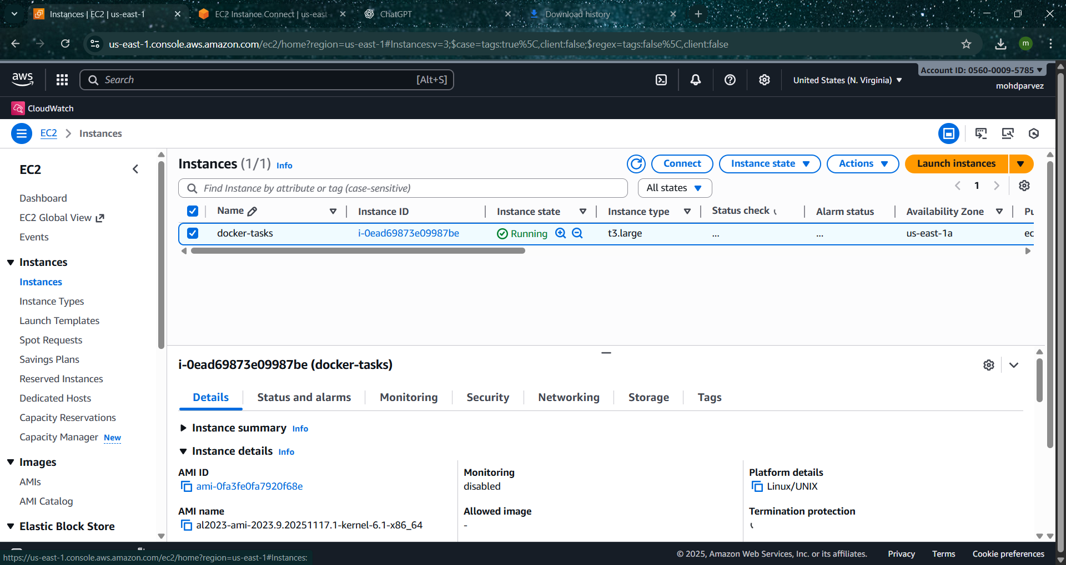
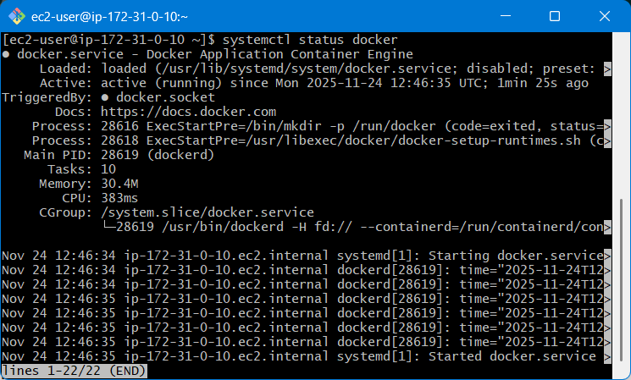

Pull 5 docker images. (nginx, Apache tomcat, ubuntu, Jenkins, SonarQube)
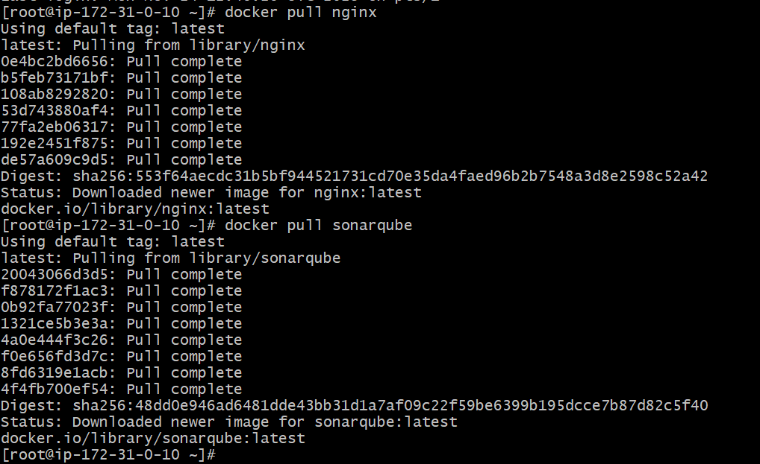
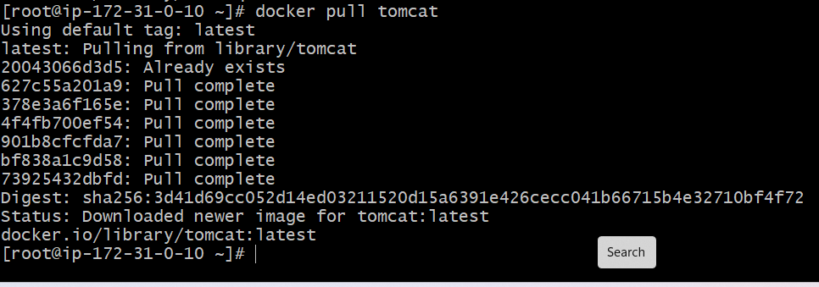
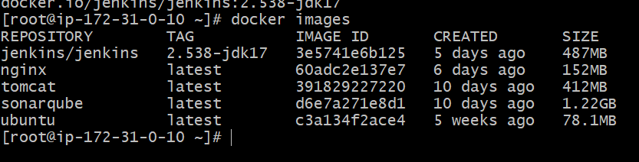
Run nginx container and expose on port 81.
Docker run -itd -p 81:80 nginx
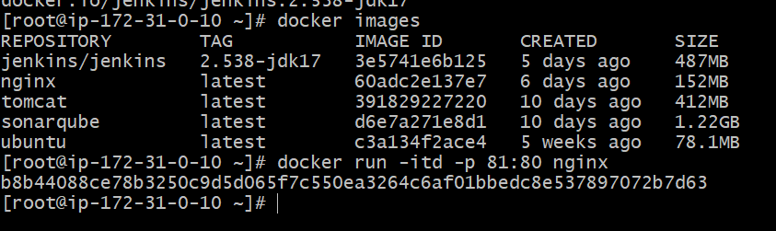
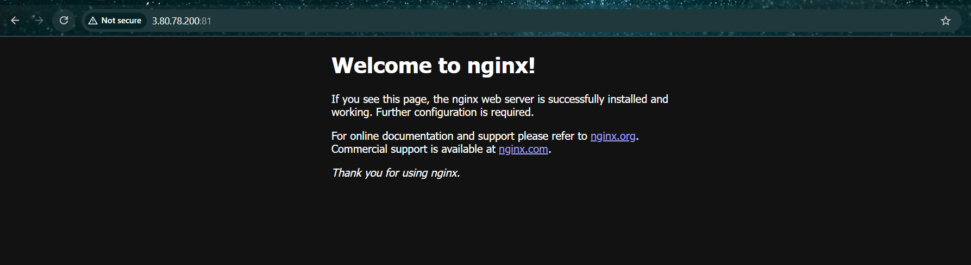

Delete the Apache tomcat image from local.
Docker rmi <container_id> or image name
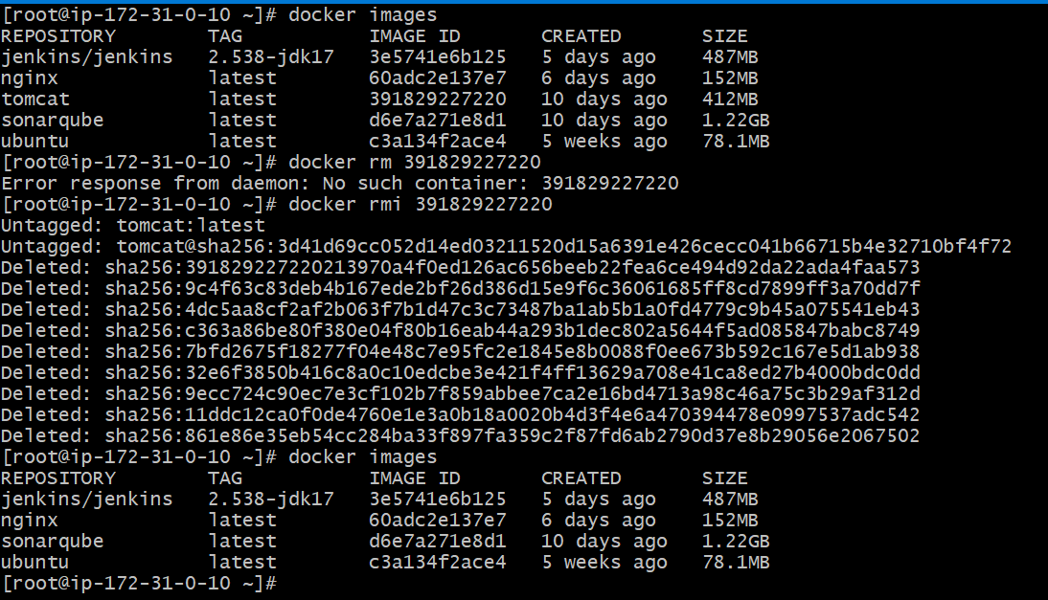

Inspect the Jenkins image, SonarQube image.
Docker container inspect <container _id>
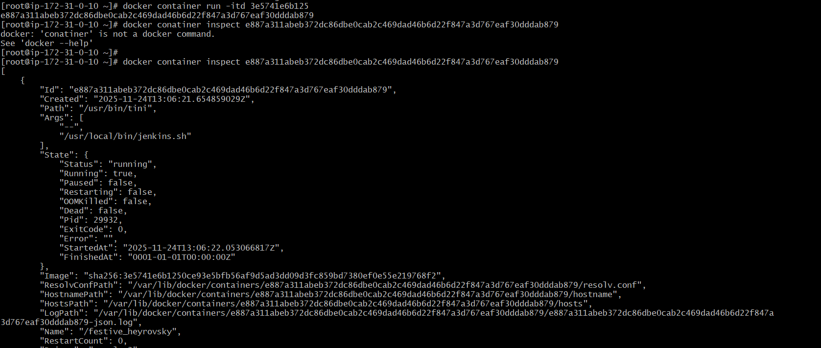
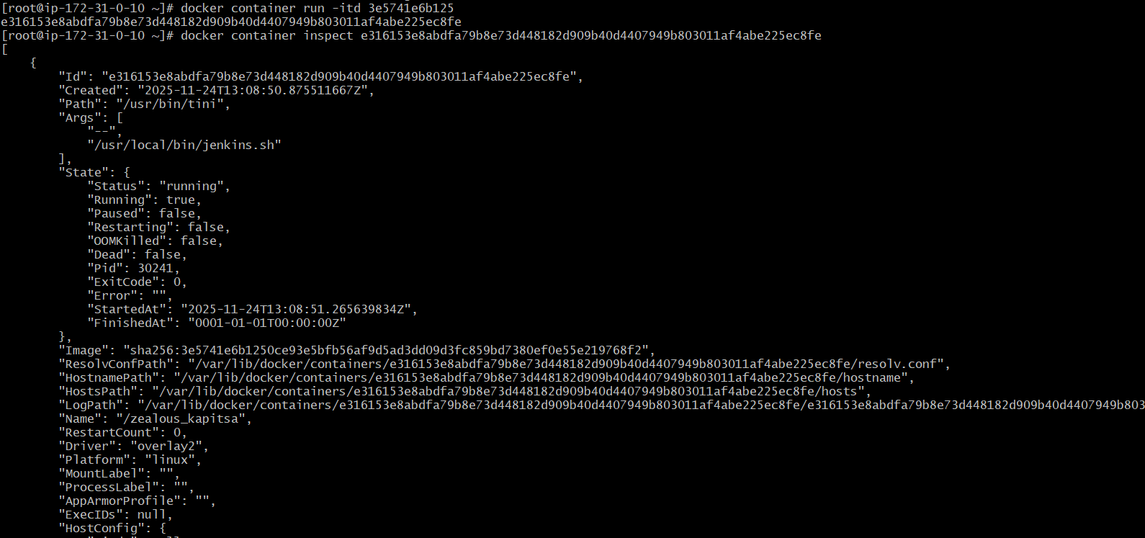

Run Jenkins container and run one sample job.
